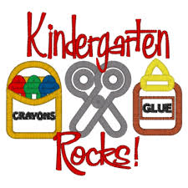

Kindergarten Classroom Supplies

3 – Boxes of Kleenex
3 – Containers of Clorox of Wipes
2 – Boxes – Classic Markers
2 – 24 Count Boxes of Crayons
2- Boxes colored pencils
4 – Glue Sticks (jumbo size preferred)
1 – Pkg. black dry erase markers
1- Box Gallon size Ziploc bags
1-Box sandwich size Ziploc bags
1-Pair scissors*
1-Pencil box with latch*
1-Set of extra clothing in bag*
1-Pair of gym shoes *
1 – each, red, blue, yellow, green spiral notebook *
1 – Computer Headphones (no earbuds please) *
1- 2inch 3 ring binder with clear front pocket*
1- SPILL PROOF water bottle *
1- small (3x5) family photo for inside of your child’s cubby*
*All items with * should be labeled with your child’s name
Art and Music supply list: 6 pack pink erasers.

- Shop the end of July-early August sales for the best prices on the above supplies.

