Second Grade Supply List
Sprunica Elementary
2021-2022

Welcome to 2nd Grade! We are looking forward to a fun and exciting year of learning!
Thank you SO much for all your help in getting your child ready for 2nd grade.

For the 2nd grade Classroom Your Child Needs:

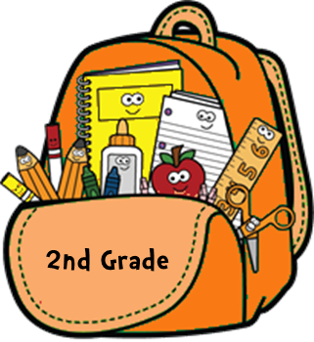
- 1 - 1 inch three-ring binder WITH clear plastic outer pockets
- 1 - 20 count page protectors
- 4 - folders WITH PRONGS
- 2 - wide-ruled spiral notebooks
- 1 - pencil pouch; label with your child’s name
(the pencil pouch will serve as your child’s classroom money wallet)
- 2 - small glue sticks
- 1 - 2 count black dry erase markers
- 1- 24 count crayons
- 1 – 12 count colored pencils
- 1 - 10 count markers
- 1 – pair of scissors
- 2 - roll of paper towel
- 1 - hand sanitizer
- 1 - disinfectant wipes
- Each child will need a book bag. Please NO book bags with wheels.
- 1- gallon size baggies
- 1-pair of headphones

Wishlist Items:
- LifeSavers candy/mints/gum (We use this for rewards and concentration.)
- Post-It notes
- 1 - pack Dixon Ticonderoga pencils

Supplies for Art, Music, and PE:
- 2- disinfecting wipes
- 1- 4 count glue sticks

Supplies for Science:
- 1- gallon size baggies

