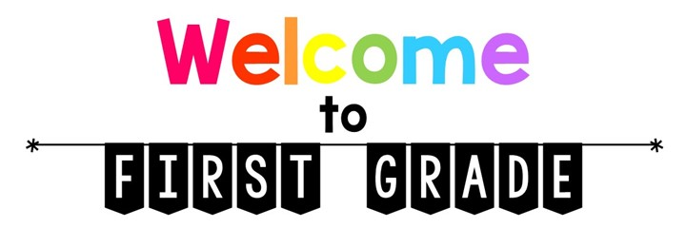

Sprunica Elementary
2021-2022
We are looking forward to a fun and exciting year of learning!
Listed below are the school supplies that your child will need in first grade.

- 2 - Cloth Pencil Pouches; label with your child’s name
- 4 - Elmer’s Glue Sticks
- 20 – Wooden #2 Pencils – PLAIN YELLOW OR WOOD
- 2 - Large Pink Erasers
- 1- 24 Count Crayola Crayons
- 1 – 12 Count Crayola Colored Pencils
- 1 - 12 Count Crayola Markers
- 2 – Large Boxes of Kleenex
- 5 – BLACK Dry Erase Markers
- 3 - Composition Notebooks
- 1 - BLUE Folder WITH PRONGS; label with your child’s name
- 1 - RED Folder WITH PRONGS; label with your child’s name
- 1 - PURPLE Folder WITH PRONGS; label with your child’s name
- 1 - YELLOW Folder WITH PRONGS; label with your child’s name
- 1 – Fiskars Scissors (blunt tip)
- 1 - Clorox Disinfecting Wipes
- 1 - Hand Sanitizer
- 1 - 2 rolls of paper towels (girls only)
- 1 - Box of GALLON plastic baggies with a zipper (boys only)
- 1 pair of headphones; label with your child’s name
- Each child will need a book bag. Please NO book bags with wheels.

- ***For Science Class: 2 Large Rolls of Paper towels
- ***For Art Class: 1 box of markers
- ***For Music Class: 1 Box of colored pencils
- ***For P.E. Class: 1 Clorox Wipes

Wishlist Items: Sugar-free gum, LifeSavers candy, Play-Doh, Stickers, post-it notes

