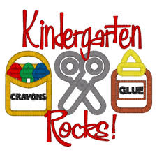

Kindergarten Classroom Supplies

3 – Rolls of Paper Towels
3 – Boxes of Kleenex
3 – Boxes of Baby Wipes
1 – Box of Gallon Size Ziploc Baggie
1 – Box of Quart Size Ziploc Baggie
1 – Boxes – Classic Markers Crayola Brand Please
3 – 24 Count Boxes of Crayons - Crayola Brand Please
12 – Pencils
1 – Large Pink Eraser
12 – Glue Sticks
1 – Large-Size Back Pack
1 – Computer Headphones

- Shop the end of July-early August sales for the best prices on the above supplies.

- No Names on Supplies Please!

